Output created by Rectangle_1A.cpp:

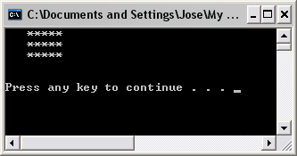

Output created by Triangle_1A.cpp:

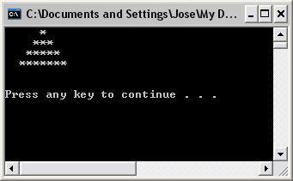

Output created by Diamond_1A:

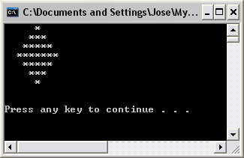

Output created by Rectangle_2A:

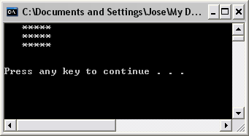

Output created by Triangle_2A:

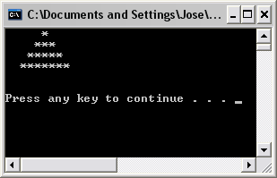

Output created by Diamond_2A:

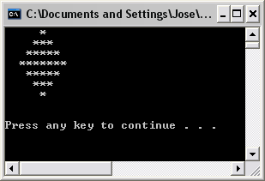

Output created by Rectangle_3A:

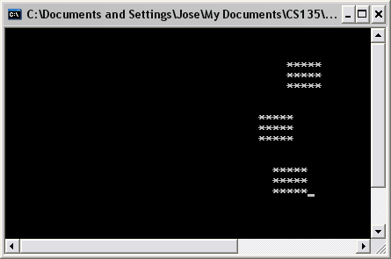

Output created by Triangle_3A:

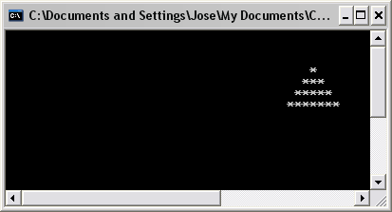

Output created by Diamond_3A: